Lake Cowichan School
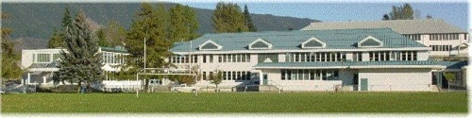
Course Selection Grades 10, 11 and 12
2026 - 2027
DIRECTIONS

- Read through the course book over the weekend.
- We will have an information session to provide you further information about course options and allow you to ask questions.
- After the information session, we will fill out the course selection form, as a group, to ensure it is done correctly.
- After the selection form is filled out, the school will take a copy and return the original to you to take home for parental approval.
- Once your parents have signed and dated the form, please return it to the office.

Ms. Jennie Hittinger, Principal
Mr. Mike Greenslade, Vice Principal

Box 40, 190 South Shore Road
Lake Cowichan BC V0R 2G0

Tel 250-749-6634 Fax 250-749-6222 Email lcsheadsecretary@sd79.bc.ca

Course Electives
* Students in Grades 11 and 12 may choose from either Grade 11 or Grade 12 courses, provided all prerequisites have been met. Please refer to the course descriptions for clarification.
Grade 10  Art Studio 10  Computer Studies 10  Food Studies 10  Film Making 10  French 10  Horticulture 10  Ice Hockey 10 (PHE)  Instrumental Music 10 (Guitar)  Japanese 10  Leadership 10  Library Science 11  Metal Work 10  Peer Counselling 10  Peer Tutoring 10  Photography 11  Social Justice 12  Studio Art 2D 10  Studio Art 3D 10  Theatre 10  Volleyball 11 (PHE)  Wood Work 10 | Grade 11 *  20th Century World History 11  Active Living 11  Art Studio 11  Athletic Leadership 11  Active Living (PHE) 11  Chemistry 11  Computer Information Systems 11  Earth Science 11  Explorations in SS 11  Film Making 11  Food Studies 11  Forensic Science 11  French 11  Horticulture 11  Ice Hockey 11 (PHE)  Instrumental Music 11 (Guitar)  Japanese 11  Journalism 11 (Yearbook)  Law Studies 12  Leadership 11  Library Sciences 11  Life Science 11  Metal Work 11  Outdoor Education 11  Peer Counselling 11  Peer Tutoring 11  Photography 11  Physical Geography 11  Physics 11 (2027-2028)  Psychology 11  Studio Arts 2D 11  Studio Arts 3D 11  Theatre 11  Tourism 11  Volleyball 11 (PHE)  Wood Work 11 | Grade12 *  20th Century World History 12  Anatomy and Physiology 12 (Bio)  Active Living 12  Art Careers 12  Art Studio 12  Athletic Leadership 12  Calculus 12  Chemistry 12  Child Care 12  Computer Information Systems 12  Environmental Science 12  Film Making 12  Food Studies 12  French 12  Furniture and Cabinetry 12  Genocide Studies 12  Geography 12  History Through Film 12  Horticulture 12  Ice Hockey 12 (PHE)  Instrumental Music 12 (Guitar)  Japanese 12  Journalism 12 (Yearbook)  Law Studies 12  Leadership 12  Literary Studies 12  Metal Work 12  Outdoor Education 12  Peer Counselling 12  Peer Tutoring 12  Photography 12  Physical Geography 12  Physics 12  Post-Secondary Preparation 12  Pre-Calculus 12  Psychology 12  Social Justice 12  Specialized Studies in Food 12 (Baking)  Studio Arts 2D 12  Studio Arts 3D 12  Theatre 12  Tourism 12  Volleyball 12 (PHE)  Wood Work 12

ABOUT THE LCS COURSE SELECTION BOOK
This Student Course Selection Handbook and Registration Guide is designed for students and parents. It contains important information regarding courses and programs at Lake Cowichan School.
Choices made for course selections, based on a thorough understanding of all options, should be made by each student in consultation with a parent or legal guardian. If you have questions about anything in this handbook, please call the school. We will do everything we can to help you with your choices. REMEMBER – your future options depend on the choices you make and your personal commitment to be successful!



Humanities Courses
English Language Arts 10

Students must complete two English option areas of focus for their Grade 10 year. Course selection forms will allow students to prioritize their selections and we hope to accommodate student choice.

CHOOSE 2 OF THE 4 OPTIONS

Option 1: Creative Writing 10 (2 credits) MCTWR10
“Do you have an interest in creative expression through language? Would you enjoy writing stories, poems, screenplays, song lyrics and other forms of creative writing?”
This option provides students with in-depth opportunities to become better writers through the exploration of the writing process. Within a supportive community of writers, students will collaborate and develop their skills through writing and design processes. This course invites students to express themselves creatively as they experiment with, reflect on, extend, and refine their writing.

Option 2: Literary Studies (2 credits) MCTST10
“Are you a reader? Do you enjoy discussing and analyzing what you read? Do you want a choice in what you read?”
This option allows students to delve more deeply into literature as they explore specific themes, periods, authors, or areas of the world through literary works in a variety of media. Giving students the choice of a range of literary topics allows them to follow their passion and increase their literacy skills through close reading of appropriately challenging texts.

Option 3: New Media (2 credits) MNMO10
“Do you enjoy watching and discussing film, video and other digital media forms? Do you prefer to communicate your ideas through presentation apps, social media, and other forms of digital communication?”
This option is designed to reflect the changing role of technology in today’s society and the increasing importance of digital media in communicating and exchanging ideas. Course work is aimed at providing students with a set of skills vital for success in an increasingly complex digital world by affording opportunities to demonstrate understanding and communicate ideas through a variety of digital and print media.

Option 4: Spoken Language (2 credits) MSPLG10
Do you want to improve your public speaking skills?
Do you want to have confidence when addressing your peers, colleagues or an audience?
Spoken Language skills are increasingly necessary in everyday, educational, and professional contexts. This option will provide students with opportunities for performance and public speaking. Spoken Language will appeal to students who enjoy public performance or oral storytelling or who want to gain more experience and skill in this area.

English First Peoples 11: Literary Studies & New Media (4 credits) MENFP11
All grade 11’s must take English First People 11 to meet the Indigenous Content Credit on grad plan.

This course satisfies the Indigenous content graduation requirement and is designed for all students, Indigenous and non-Indigenous, who are interested in using non-traditional texts to learn about the experiences, values, beliefs and lived realities of First Peoples. A key feature of the course is its focus on authentic First Peoples' voices.

English Studies 12 ENST-12
The English Studies 12 course builds on and extends students’ previous learning experiences in Grade 10 and 11 courses. First Peoples’ themes will be woven throughout the course. It is designed for all students and provides them with opportunities to:
- Refine their ability to communicate effectively in a variety of contexts and to achieve their personal and career goals
- Think critically and creatively about the uses of language
- Explore texts from a variety of sources, in multiple modes and that reflect diverse worldviews
- Contribute to reconciliation by building greater understanding of the knowledge and perspectives of First Peoples
- Expand their understanding of what it means to be educated Canadian and global citizens

English First People 12 MENEP-12
This course satisfies the Indigenous content graduation requirement. This course is grounded in the First Peoples’ Principles of Learning. It is designed for all students, Indigenous and non-Indigenous, who are interested in delving deeply into First Peoples ’oral and written literature and visual texts in a range of media. The course focuses on the experiences, values, beliefs, and lived realities of First Peoples as evidenced in various forms of text, including oral story, poetry, song, performance, film, and prose. A key feature of the course is its focus on authentic First Peoples ’voices (i.e., historical or contemporary texts created by or with First Peoples).

Literary Studies 12 MLTST 12
This course can be taken in a class format or through an individually paced option. The goal of Literary Studies 12 is to enhance literacy and knowledge of literature. Every unit includes paragraph writing and analysis of literature. The units are organized chronologically as the works are presented in historical context. A major inquiry project is assigned at the beginning of the course and is due at the end and there are no formal tests in this course. Literary Studies 12 meets the academic subject requirement for university entrance.

Spoken Language 12 SPLG12
This course is a self-paced, year-long course that meets academic requirements for university entrance. The focus of the course is creation and presentation of speeches at school, hosting assemblies, and participating in community events. Students will also be looking at how these presentations and speeches are structured. One of the course requirements is to create audio books for younger students to help them access texts. Students can use participation in theatre productions or the Cowichan Lake Ambassador Program to help meet the course requirements for Spoken Language 12.

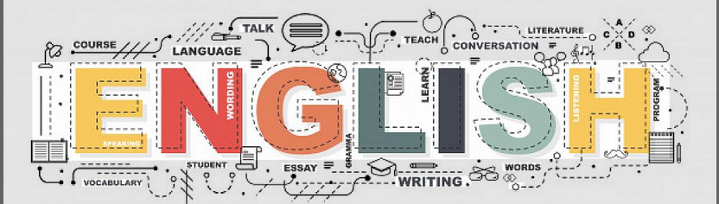

Social Studies
Social Studies 10 Canada and the World – 1919 to the present MSS—10
This course provides students with an understanding of their place in the world and connections between the human and natural environment. Students will continue to develop the skills required to make informed decisions about issues. This course has a strong history component as well as human geography and the structure of Canadian government. Social Studies 10 is a mandatory course for all students.

Social Studies 11 Explorations in Social Studies MEPSS11
Explorations 11 can serve one of two diverse purposes for students. It is meant to be a quick and condensed way of meeting the Social Studies requirement for graduation. Explorations 11 also provides students with a sampling of Grade 12 courses offered at LCS, so they have a better understanding of the different disciplines within the social sciences. Topics will include 20th century world history, political studies, economics, geography, and social justice. There will be no big projects or a final exam in this course.

Genocide Studies 12 MGENO-12
This intense and graphic course will explore the history of genocides of the 20th century. Case studies will range from indigenous peoples and cultural genocide to mass exterminations of the Armenian genocide to Rwanda and other African regimes. A major emphasis on the Holocaust will be applied to this course. This four-credit course is available and meets Ministry of Education Social Studies requirements for graduation and is an academic subject requirement for university entrance.

Physical Geography 12 MPGEO12
PRE-REQUISITE: Socials 10. STRONGLY RECOMMENDED: 70% or higher in science 10 and socials 10.
Are you interested in learning more about natural disasters such as the possibility of an earthquake or wildfire in our region? Do you wonder how our interactions with the environment affect us and the planet? In this course, you will study the interrelationship of people and places, as well as resource management. You will explore the issues that affect us in Lake Cowichan and globally, through hands-on experiments and projects to determine how to make our systems more sustainable. This course can be used for a required grade 11 or 12 social studies credit and is a great option for students with an interest in science. Students taking this course should have good overall work habits.
BIG IDEAS include: PRE-REQUESITE: Socials 10
- Geo Inquiry and Global Systems STRONGLY RECOMMENDED: 70% or higher in
- Natural processes and disasters science 10 and socials 10
- Weather and climate

20th Century World History 12 MWH--12
This course will provide students with an opportunity to explore world history from 1919 to 2000. Topics may include, but are not limited to:
- Czarist and Communist Russia
- Japanese Imperialism
- Weimer and Nazi Germany
- Struggles for Decolonization and Independence
- Global recognition of Human Rights
- Nuclear Arms Race and the Cold War and the Collapse of the Soviet Union
- Transformation of China, Apartheid, and Middle Eastern Conflicts
The course will be inquiry and project based. Research, class discussion, debate, and presentation skills will be developed, as well as participation in whole class discussion, small group and individual work. This four-credit course is available and meets Ministry of Education Social Studies requirements for graduation. It also meets the academic subject requirement for university entrance.

Law Studies 12 MLST-12
Students in this course will, by discussion and debate, learn about their legal rights and responsibilities in Canadian society. Topics include: The Charter of Rights and Freedoms, civil law, criminal law, family law, and provincial and federal court systems. This course also includes a day at the courts. This four-credit course is available and meets Ministry of Education Social Studies requirements for graduation. This course meets the academic subject requirement for university entrance.

Social Justice 12 MSJ--12
“Talk is cheap! Action speaks louder than words!”
Social Justice is a proactive course, where students become actively engaged in their community. We explore the many current social injustices and their impacts on our society, then we try and do something positive to make an impact on those injustices. The course focuses on a wide variety of social justice issues and moves students through three stages of social engagement. Initially, awareness is developed as students begin to explore issues from various perspectives. Next, students analyze issues to gain a more thorough understanding of them. Finally, students pick specific issues to focus on and develop their own personal action plans for making real change in an area they feel passionate about. An action plan is required to earn credit for this course. This four-credit course is available and meets Ministry of Education Social Studies requirements for graduation and university academic entrance requirements.

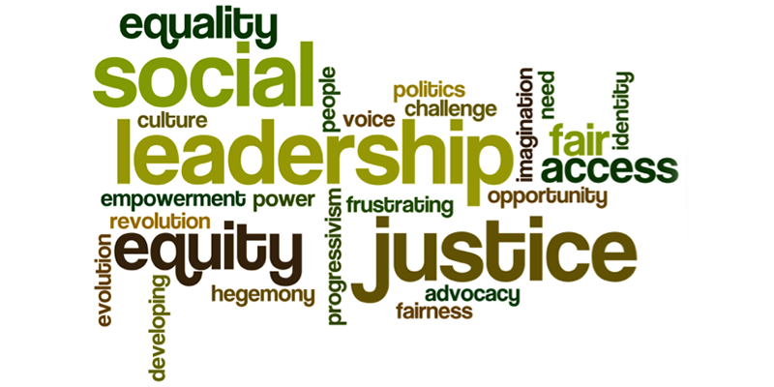

Math Courses
MATHEMATICS PATHWAYS
There are two math courses at the Grade 10 level and three in the Grade 11. There are two pathways at the Grade 12 level. Each is intended to lead into the next, as shown below.

Each course will build on the following skills:
- Reasoning and modelling
- Understanding and solving
- Communicating and representing
- Connecting and reflecting

Workplace Mathematics 10 MWPM-10
This course is designed for those planning to go from high school into the workforce or into some trades. Emphasis is on practical skills such as measurement, unit conversion, basic finances, practical geometry and some basic algebra. Although still challenging, this course places less emphasis on theory than on practical applications of math. Most technical schools will require this course for entrance. This course leads to Workplace Math 11. Students who want to keep as many options for the future as possible open, may consider taking both Grade 10 math courses.

Foundations and Pre-Calculus Math 10 MFMP-10
This course is intended for students who will carry on to post-secondary education. This a fairly rigorous, yet broad ranging course. It will cover:
- Number: multiplication and factoring of polynomials, and financial literacy
- Computational Fluency: powers with integral exponents
- Geometry and Measurement: primary trigonometry
- Data & Probability: sequences and series

Workplace Mathematics 11 MWPM-11
This course is strongly recommended for students who are planning on entering the workforce directly after high school, or who are planning on pursuing a career in the trades industries. Topics covered may include reasoning, rates of change, measurement, and statistics. This course satisfies the grad requirements for the Ministry of Education. Students wanting to enroll should have successfully completed Apprentice and Workplace Mathematics 10 or have permission from the instructor.

Foundations of Mathematics 11 MFOM-11
PRE-REQUISITE: Foundations 10, Pre-Calculus 10. STRONGLY RECOMMENDED: 70% or higher in Foundations 10 or Pre-Calculus 10.
This course is strongly recommended for students who are planning on pursuing post-secondary studies in the arts or the humanities. Topics studied may include logic and reasoning, functions, geometry, and statistics. Students who successfully master the learning outcomes of this course may continue on to Foundations of Mathematics 12. This course satisfies the Ministry of Education’s mathematics graduation requirements. This course involves a high level of reading skills due to the emphasis on problem solving. Students who are planning on pursuing post-secondary studies in math or sciences should take Pre-calculus Mathematics 11. A final grade of 60% or higher in Foundations and Pre-calculus Mathematics 10 is strongly recommended.

Pre-Calculus 11 MPREC-11
PRE-REQUISITE: Foundations 10, Pre-Calculus 10. STRONGLY RECOMMENDED: 70% or higher in Pre-Calculus 10.
This course is designed for students intending to pursue post-secondary programs that require the study of theoretical mathematics. It will cover the following topics:
- Number: powers with rational exponents, radicals, financial literacy
- Computational Fluency: exponential functions, rational expressions, quadratic functions
- Geometry and Measurement
A final grade of (70%) or higher in Foundations of Mathematics and Pre-Calculus 10 will help ensure success in this course, which satisfies the mathematics graduation requirements.

Pre-Calculus Mathematics 12 MPREC-12
PRE-REQUISITE: Pre-Calculus 11. STRONGLY RECOMMENDED: 70% or higher in Pre-Calculus 11.
Designed for those students interested in the pure and applied sciences, as well as the arts, and are bound for university. Focus will be upon the more abstract and theoretical concepts of mathematics. Study of math at this level will help develop logical thinking, problem solving, analytical thinking, supporting your thinking with clear eloquent and well-organized communication, and spatial/relational skills. This course meets academic university entrance requirements.
Topics Include: Problem solving, functions, logarithms, trigonometric functions, equations and identities, sequences and series.

Calculus 12 MCALC12
PRE-REQUISITE: Pre-Calculus 12. STRONGLY RECOMMENDED: 70% or higher in Pre-Calculus 12.
Students will be introduced to the ideas of calculus. Topics will include the history of calculus, functions, graphs and limits, derivatives and integrals. This course meets academic university requirements.

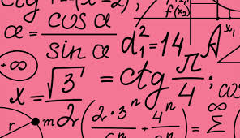

Science Courses
Science 10 MSC--10
This course introduces students to all future science specialty areas: Biology, Chemistry and Physics. It covers a wide variety of topics.
BIG IDEAS include:
- Genetics
- Laws of Energy
- Atomic Structure & Radioactivity
- Chemical Reactions
- Formation of the Universe

Science For Citizen 11 MSCCT11
PRE-REQUISITE: Science 10.
This course focuses on real work, practical applications of science. If explores scientific topics that a person encounters in their daily lives and in a work environment. The course also explores the science behind numerous environmental concerns and forensic investigations. This course can be used to fullfil the Science 11 requirement for graduation.

Life Sciences 11 MLFSC11
PRE-REQUISITE: Science 10. STRONGLY RECOMMENDED: 70% or higher in Science 10.
This course takes us on a journey from the tiny cell to complex creatures. In Life Science students will be studying all forms of life through numerous types of labs. Students taking this course should have good overall work habits.
BIG IDEAS include:
- Characteristics of Living Things
- Process of Evolution
- Taxonomy
- Microbiology
- Plant & Animal Biology

Chemistry 11 MCH—11 (offered in 2026-2027)
PRE-REQUISITE: Science 10. STRONGLY RECOMMENDED: 70% or higher in Science 10, Foundations 10, and Pre-Calculus 10.
This Chemistry program will stimulate student interest in the natural world, develop skills in scientific inquiry, and broaden the students’ chemical knowledge. Students will study the concepts involved in the behavior, identification, characterization and transformation of matter. Laboratory techniques and accurate analysis of data will be emphasized. Through laboratory work, problem-solving skills will be developed. There is a large math component to this course.

Physics 11 MPH—11 (offered in 2027-2028)
PRE-REQUISITE: Science 10. STRONGLY RECOMMENDED: 70% or higher in Science 10, Foundations 10, and Pre-Calculus 10.
Interested in the universe around you? This is the study of the interaction between energy and matter. There is not much that doesn’t fall into those two categories. Come and learn the principles that govern everything in the universe.
BIG IDEAS include:
- Motion
- Forces
- Energy
- Electric circuits
- Waves

Earth Science 11 MESC-11
PRE-REQUISITE: Science 10.
This course can be used to fulfill the Science 11 requirement for graduation and can lead into Geography 12.
BIG IDEAS include:
- Earth Materials (rocks, minerals and their economic and environmental impact)
- Plate Tectonics
- Atmospheric Science and Climate
- Oceanography and Hydrosphere
- The Earth within our Solar System

Anatomy and Physiology 12 MATPH12
PRE-REQUISITE: Science 10. STRONGLY RECOMMENDED: 70% or higher in Science 10 or Life Science 11.
Have you ever wondered how the human body functions? This course explores the biochemistry of the cell, genetics, and the functions all the major systems of the human body. While not a requirement, Chemistry 11 is an asset for this course. This course meets academic university entrance requirements.
BIG IDEAS include:
- Homeostasis
- DNA and cells
- Organ systems

Chemistry 12 MCH—12 (offered in 2027-2027)
PRE-REQUISITE: Science 10 and Chemistry 11. STRONGLY RECOMMENDED: 70% or higher in Chemistry 11 and Pre-Calculus 11.
Chemistry 12 uses the information gained in Chemistry 11 to study the basic principles of change in matter. Reasonable algebra skills are required. This is a required course for many health science careers. This course meets academic university requirements.
BIG IDEAS include:
- Reaction Kinetics
- Dynamic Equilibrium
- Solution Chemistry
- Acids and Bases
- Oxidation and Reduction

Physics 12 MPH—12(offered in 2026-2027)
PRE-REQUISITE: Science 1. STRONGLY RECOMMENDED: 70% or higher in Science 11.
Delve deeper into the most fundamental science. This course will improve your skills of questioning and predicting, processing and analyzing data, scientific thinking and communicating. Physics 12 will be offered every other year, alternating with Chemistry 12, so plan ahead. This course meets academic university requirements
BIG IDEAS include:
- Motion
- Relativity
- Circular motion
- Fields (gravitational, electric and magnetic)
- Momentum
- Electromagnetic induction

Environmental Science 12 EVSC-12
PRE-REQUISITE: Science 10. STRONGLY RECOMMENDED: 70% or higher in Science 10 and Socials 10.
Do you wonder about forest fires, low lake levels, or the health of animals in our ecosystems? In this course, you will study how human actions affect water, forest, food, and climate systems. You will explore issues that affect us in Lake Cowichan and globally, through hands-on experiments and projects to determine how to make our systems more sustainable. This course can be used for a required grade 11 or 12 science credit and is a great option for students with interests in social studies or ecology. Students taking this course should have good overall work habits.

BIG IDEAS include:
- Local and global water issues
- Climate change
- Forest and food systems
- Sustainable living



Physical Education
The choices students have are designed to encourage students to select a balance of team and individual sports. We are offering a variety of sports including unique opportunities such as golf, forest games and First Aid. Units are usually 10 -12 classes in length and new units take place every month.

Physical Health Education 10 MPHE-10
Physical Education 10 is a required course for graduation and is designed to provide students with a strong foundation in a wide range of physical activities. The course introduces students to both individual and team sports, with an emphasis on active participation, skill development, and lifelong physical literacy. Assessment is based on 50% active participation, 30% skill development, and 20% knowledge-based learning. Students will have some opportunity for individual activity choice.

Active Living ACLV11 / ACLV 12
The Senior PHE program is based on the principles of choice, inclusion and participation. Our objectives are to provide students with a basic knowledge and skill level to play a great variety of sports and most importantly, to create opportunities to be active, and have fun all the while instilling the motivation to lead an active lifestyle. While students will participate in PHE with their scheduled PHE teachers, they are presented with a variety of curricular choices for each teaching unit. The emphasis for our senior students will be on fair play and sport strategy, less on skill development and basic knowledge. Our health units will focus on the following topics:
- Healthy Lifestyles / Mental and Sexual Health
- Human Anatomy
- Sports Injury and Prevention

Ice Hockey 10 MPHE--10 (Hockey)
Ice Hockey 11 MPHE--11 (Hockey)
Ice Hockey 12 MPHE--12 (Hockey)
- Ice hockey is a PHE based course that focuses on skill development and activity. This course is open to new, developing, and advanced hockey players. On-ice and dry land classes will occur from September to February. Students will improve their hockey skills, their personal training levels, and gain experience coaching and officiating
- Prerequisites: Students must have their own hockey gear.
- Note: This course comes with a $50 fee to cover additional costs to the program. If this fee will create a financial hardship, please speak to an administrator prior to registering.

Fitness and Conditioning (2 CREDIT) 10 YFC--10 (Dry-land PE Component)
Fitness and Conditioning (2 CREDIT) 11 YFC--11 (Dry-land)
Fitness and Conditioning (2 CREDIT) 12 YFC--12 (Dry-land)
Even if you are not in the hockey program, you can join the dry-land component, if space allows. Develop cardiovascular fitness, strength training, and learn about sports nutrition and sports psychology.

Volleyball 10 YVBW10
Volleyball 11 YVBW11
Volleyball 12 YVBW12
Volleyball is a full year PHE course that focuses on skill development and activity. Students will improve their skills, learn strategies, and become Level One certified officials, providing them an opportunity to earn money refereeing.
- Note: This course comes with a $25.00 fee to cover additional costs to the program. If this fee will create a financial hardship, please speak to an administrator prior to registering.

Athletic Leadership 11 YALE-11
Athletic Leadership 12 YALE-12
This course has been developed to allow students with an interest in athletics an opportunity to explore the many aspects of athletics from:
- first aid training and certification with a focus on athletic injuries,
- tournament organization and management
- refereeing
- volunteering for various athletic events in and around the community
- introduction to various lifetime activities and physical education
Students who can demonstrate knowledge and understanding of the concepts covered will receive their Standard First Aid and CPR C certification through Red Cross and will be given instruction on treating athletic injuries. Students will be required to volunteer for required hours (30 to 40, grade dependent) throughout the course during many athletic events provided, such as:
- school tournaments
- school intramural leagues
- local elementary intramural leagues
- community events

Students will discuss and practice leadership skills and learn to work as a team with a focus on helping the local community. This is reflected in the learning outcomes which involve social and community issues and kinesthetic learning, as well as developing interpersonal skills. The course will provide students the opportunity to develop their social skills, as well as help advance the athletic skills of students in the community and their own with the opportunity to volunteer their time and knowledge

Outdoor Education and Discovering Nature 11/12 MODED11 MODED12

This course is designed to provide students with hands-on experience and knowledge about outdoor environments, emphasizing the importance of understanding and respecting nature. Through a combination of field trips, classroom learning, and practical skills training, students will develop an appreciation for the outdoors and gain essential knowledge for safely and responsibly enjoying the wilderness.
Course Goals:
  - To introduce students to local wilderness areas and trails.
  - To develop basic outdoor skills, including navigation, safety, and survival.
  - To promote environmental awareness and conservation.
  - To instill a sense of responsibility and stewardship for the natural world.
  - To incorporate Indigenous perspectives on nature and the environment.

Career Life Education / Career Life Connections
Career Life Education 10 MCLE-10
This course is offered in Grade 10. It focuses on workplace safety, preparation for post-secondary life, budgeting and income taxes, resumes and cover letters, post-secondary education options, and scholarship opportunities. This course is a graduation requirement.

https://curriculum.gov.bc.ca/sites/curriculum.gov.bc.ca/files/curriculum/career-education/en_career- education_10-12_career-education-guide.pdf

Career Life Connections and Capstone Project 12. MCLC-12
Grade 12 students in BC will be completing a Career Life Connections (CLC) package and presenting a Capstone Project as a graduation requirement. Each half of the course is worth 50% of the final mark and a percentage will be given for the course. Students must pass each section of the course to earn credit for the class.
The CLC package will be handed out in September and need to be completed, in full, by the end of the year.
The Capstone Project is a cumulating project, presentation, or performance showcasing students' learning in a meaningful, relevant product. The Capstone Project consists of a proposal, mentorship connection, portfolio, presentation, and a reflection paper. Students will select a strand from one of the following six areas:
- Research/Experiment should be at least 12 pages in length with proper citing
- Project Construct a tangible object from design to building stages
- Event research, create, and host your own event
- Career/Entrepreneur starting a new business initiative from the ground up
- Portfolio Creation of a digital or tangible portfolio of items
- Service 40+ hours in a community or service project, includes an action plan
- These projects can be used as credit for other courses, as well as used for a district scholarship presentation in the spring.
- Students will be required to meet with the CLC teacher, weekly, to show progress in their project. The students will also need to choose a mentor, from the community or school, to connect with about their project as part of the mark.
The Capstone includes, but is not limited to, three components:
1. Self-assessment and critical analysis: Students reflect on experiences in school and out of school, assess development in the Core Competencies, and share highlights of their learning journey and preferred next steps.
2. Process and representation: Informed by their critical analysis, and connecting to their plans for post- graduation, students engage in a deeper learning process with intent as they design, assemble, and share their capstone representation.
3. Showcase and celebrate: Students present their learning journey, including plans for post-graduation, to a relevant audience.

Post-Secondary Preparation 12 YSEVC2B
This year-long course is aimed at Grade 12 students who are in the process of registering for post-secondary school. Students will be working through finding and applying for university, preparing for scholarships, budgeting for tuition and living expenses, learning about on-campus resources, and general “how will I survive my first year??” skills. Students taking this course must be on the path to any post-secondary program.


Applied Skills
Computer Studies 10 MCMPS10
Computer Information Systems 11 MCINF11
Computer Information Systems 12 MCINF12
Information Technology 10 is a general computer course intended for students at ALL levels of experience and ability with computer technology.
Topics covered will include:
- Computer Hardware
- Office Applications (word processing, spreadsheets, presentation software)
- Graphic Design (illustration & photo editing)
- Animation
- Electronic Communications (internet technologies and web page design)
- Digital Video (filming and editing a short movie)
Information Technology 11 and 12 have students developing the skill set from InfoTech 10 in greater depth, with the opportunity to focus more on areas of interest.

Woodwork MWWK-10
Woodwork MWWK-11
Woodwork MWWK-12
This full semester course enables students to experience the complete wood shop facility. All students must complete a unit on shop and machine safety and will receive instruction on hand and power tools, advanced wood craft processes, joinery and finishing.
Students in Grade 10 will be required to complete a few compulsory projects (example: jewelry box). Students in Grade 11 and 12 will have the opportunity to design and build a taper leg side table, demonstrating previously learned skills and processes; following which they will have earned the freedom to create projects of their own choosing.
Clocks, picture frames, cutting boards, lathe turnings (bowls, spindles), boxes, chess boards and trays are only a few samples of an infinite array of projects one can create.

Metalwork MADM-10
Metalwork MADM-11
Metalwork MADM-12
This course introduces students to core metalworking skills through a sequence of hands-on projects that build confidence and technical ability. Students will work with mild steel and develop sage material handling practices while shaping and forming components through a series of projects. Students will learn basic heat-treating concepts and gain introductory experience on the metal lathe. The course also includes a welding unit in which students complete either a personal project or a structured build such as a small steel container. Students set up welding equipment, prepare materials, and practice both stick and MIG welding. Throughout the course, students develop planning skills, improve accuracy, and apply fundamental fabrication techniques that prepare them for further work in the trades.

Furniture and Cabinetry 12 MTFAC12
This is a beginning course consisting of compulsory and elective work. Students will be introduced to the theory of the basic joints used in cabinetry and their uses in required projects. The course covers use of hand tools, power tools, abrasives, adhesives and some finishes. Measurement, layout procedure, cutting lists and production paths, which lead into small project construction, will also be covered. Activities will include building several compulsory projects using many hand tools in the shop and building several compulsory projects using some of the machines in the shop. Students may have time to design and build at least one elective project.

Psychology 12 YPSYC2A
Psychology 12 is an academic course designed to introduce students to key concepts, theories, and research methods in the scientific study of human behaviour and mental processes. Throughout the course, students explore a variety of psychological topics including biological bases of behaviour, learning and cognition, personality development, social interaction, psychological disorders, and therapeutic approaches. Students will develop critical thinking and scientific literacy by examining how psychologists investigate behaviour, evaluate evidence, and apply psychological principles to real-world issues. Emphasis is placed on understanding human diversity, ethical considerations in research, and the role of psychology in daily life. This course encourages inquiry, self-reflection, and an appreciation for the complexities of individual and social functioning. Successful completion prepares students for further study in psychology, social sciences, and related fields while fostering skills valuable for post-secondary studies and lifelong learning.

Food Studies 10 MFOOD10
Food Studies 11 MFOOD11
Food Studies 12 MFOOD12
In this course, you will learn how to cook a variety of meals and how to bake. You will also learn about healthy eating, meal planning, and whole food lifestyles. We look at sourcing ingredients and growing our own food. Sustainable agriculture is covered as well as a focus through project based learning.

Specialized Studies in Food 12 (Baking) MSPSF12
If you love to bake, this is the course for you. Throughout this course, you will learn practical theory and practice your skills continually. Topics will include:
quick breads
- pastry
- yeast breads
- cookies
- cakes
- cake decorating
- food art
- commercial production
- presentation of food
Prerequisite: Food Studies 10 is recommended

Library Sciences 11 YLSCI11
The purpose of Library Science 11 is to give students hands-on experience in the services and management of a library. Students will learn while providing a broader set of skills and competencies applicable in high school, business, and other professional environments.

Tourism 11 MTRM-11
Tourism 12 MTRM-12
The tourism industry is one of the largest job-producing sectors of our economy. Tourism 11 focuses on an introduction to the tourism industry in BC including the attitudes and transferable skills of the tourism professional. Tourism 12 moves into international travel planning, tourism operations, and the business side of tourism. Students taking Tourism 11 and 12 will be required to complete volunteer or work experience in the tourism sector as part of their mark.

Horticulture 10 YAED-0A
Horticulture 11 YAED-1A
Horticulture 12 YAED-2A
Horticulture is open to grades 10 – 12. These practical hand-on courses will teach you about how to plant, and maintain a permaculture food forest inside and out at LCS, as well as the philosophy behind the permaculture movement. We will be working with gardens outside as well as the tower gardens inside. There will also be opportunities to visit some established food forests in the community. David Suzuki said,
“what Perma culturalists are doing is the most important activity that any group is doing on the planet.” Come join the fun.

Child Development and Caregiving YCHD-11
Child Development and Caregiving MCDAC12
Family studies is a social science that explores the stages of growth and development from conception to old age. Studying the development of children can help you learn about yourself and prepare you for the future. We will look at the many categories of jobs that are related to working with children from entry level to professional. We will learn about and discuss important issues that affect the growth and development of children and families in our community and the world.

Peer Counselling 10 YIPS-0A
Peer Counselling 11 YIPS-1A
Peer Counselling 12 YIPS-2A
This course is a year-long course that only meets in the first semester followed by individual projects and work for the second semester. Peer Counselling gives students the opportunity to be trained in interpersonal communication, observation, listening and empathetic communication skills, conflict resolution, and working with younger students. Peer counsellors work mainly with our elementary students at LCS. and do group activities in the class as well as work with students individually. This is a good course for students who are interested in pursuing a career in the mental health or counselling fields or who are interested in working with children in the future.

Leadership 10 YCPA-0A
Leadership 11 YCPA-1A
Leadership 12 YPCA-2A
Students in Leadership will develop organizational and leadership skills through organizing and participating in both school and community events. We also look at leadership philosophy and styles. The class meets outside the timetable at lunch. Evaluation will be based on participation in class and follow through on events. Students have some options within the course to focus on athletics, elementary school, or other areas of special interest.

Peer Tutoring 10 YIPS-0B
Peer Tutoring 11 YIPS-1B
Peer Tutoring 12 YIPS-2B
Peer Tutoring is designed to challenge students who are motivated, co-operative, and skilled. Tutors are responsible for helping others to learn. In the process, tutors learn:
- study habits
- learning styles
- communication skills
- memory techniques
- productive thinking skills
- will act as student assistants in various courses

Modern Languages

French 10. MFR--10
In this course, you will participate in a variety of listening, speaking, reading, and writing activities using authentic documents. You will build on what you learned in Grade 9, increasing your vocabulary and your communication skills.

French 11 MFR--11 / 12 MFR--12
This is a continuation of listening, speaking, reading, and writing activities using authentic documents such as food labels, ads, poems, stories, music etc. You will build on what you have learned in past French courses, becoming a stronger French communicator.

Japanese 10 MJA--10
Students will become familiar with Japanese characters and will build up conversational skills. The cultural aspect of the course focuses on Japanese history. This introductory course must be completed before moving on to Japanese 11.

Japanese 11. MJA—11 / 12 MJA--12
This course is a continuation of Japanese 10. Learning new kanji is a focus in this course as well as expanding vocabulary and sentence structures. Modern day Japan is the subject of our cultural studies. Conversational skills are increased.
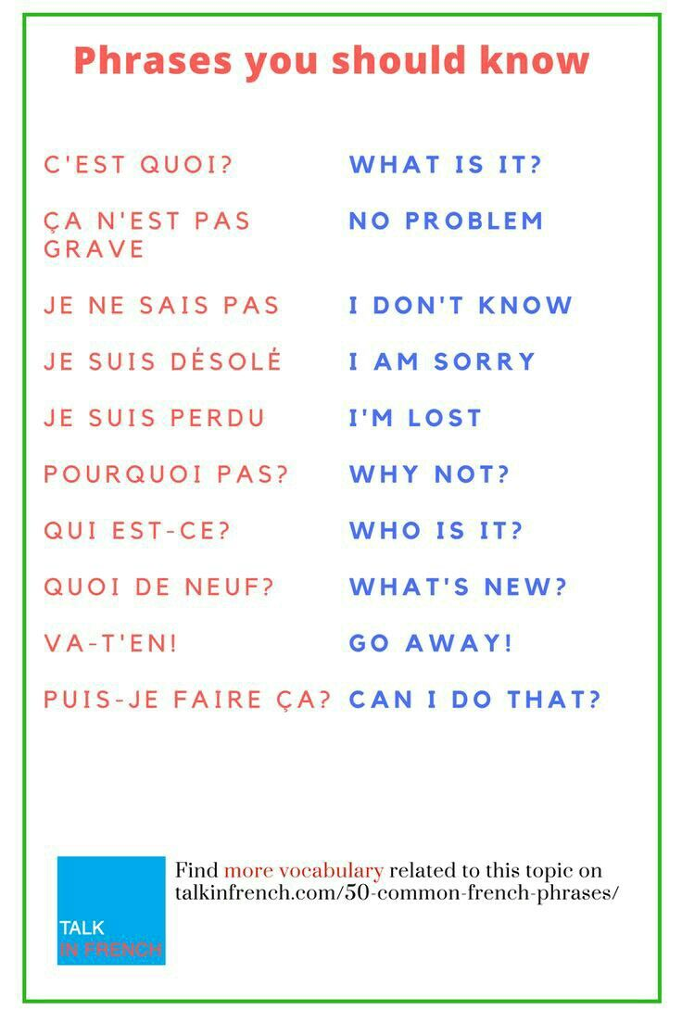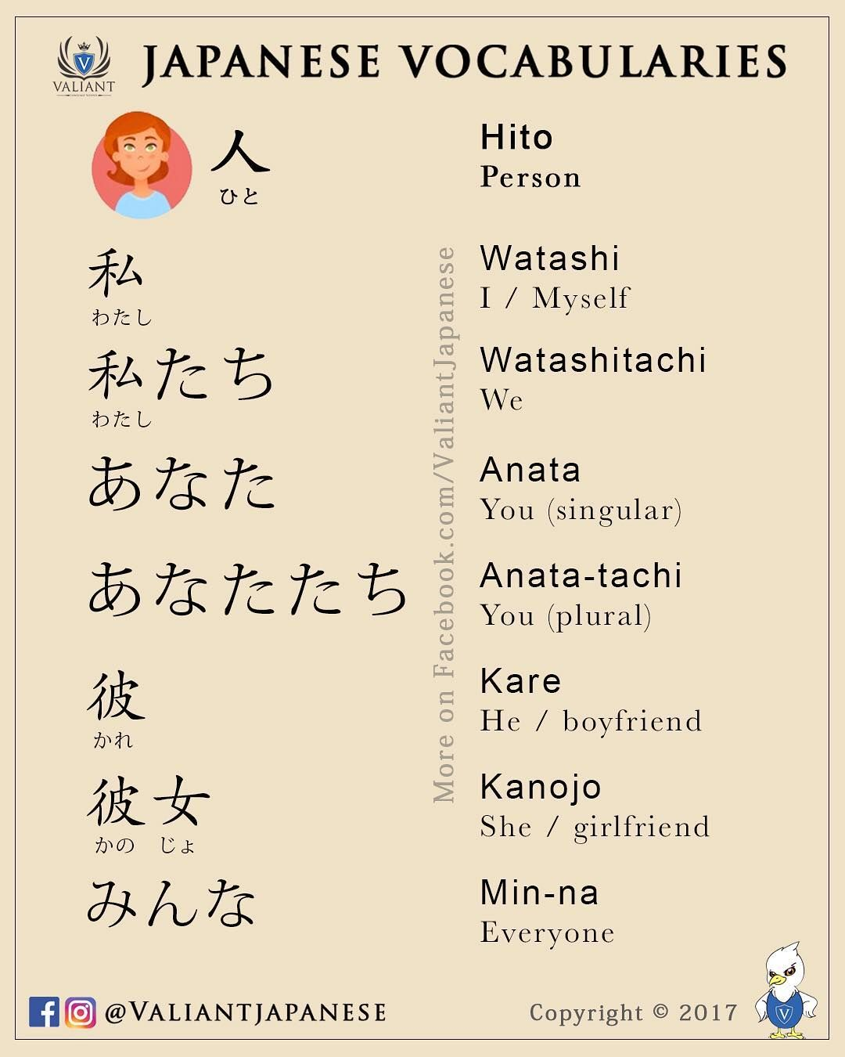

Fine Arts
Instrumental Music (Guitar) 10 MMUGT10
Instrumental Music 11. MMUGT 11
Instrumental Music 12 MMUGT 12
Guitar introduces students to the foundational techniques and concepts of guitar performance. Students will learn proper playing posture, chord shapes, strumming and fingerpicking patterns, and reading music and tablature. The course emphasizes personal expression and creativity while helping students develop confidence as musicians.
Students explore a variety of musical styles—from pop and rock to blues and folk—and learn how music can express connections to culture, identity, and community. Opportunities for solo and small-group playing help students build listening skills, perseverance, and musical independence.
Students will also have the chance to create their own music, experiment with different sounds, and develop a personal playing style.
This course is perfect for beginners or students with some experience who want to build strong musical foundations in a fun, hands-on environment.

Theatre 10 MDRM-10
Theatre 11 MDRM-11
Theatre 12 MDRM-12
The main focus of this course is to actively explore various dramatic forms and techniques, allowing students to experience all aspects of the theatre, from acting and stage production to directing and script writing. During the first part of the course the class will focus on mime, movement, improvisation, speech and vocal development along with extensive script work and development. The second part of the course is the performance piece where the class will stage a school wide production for the community.

BIG IDEAS Include:
- Drama develops creativity, innovation and collaboration
- Ideas and beliefs conveyed through Drama can affect the actor, audience, and environment
- Drama offers ways to increase personal growth, risk-taking and learn more about one’s personal identity

Art Studio 10 MVAST10
Art Studio 11 MVAST11
Art Studio 12 MVAST12
This course offers students the opportunity to develop their creative and technical skills in various media, as well as experience growth in image development. Students will learn to become independent in an art studio, creating their own projects in the areas of drawing, painting, ceramics, printmaking, and multimedia.

Yearbook 11/12 YCCT-2A
Yearbook is an introduction to desktop publishing. Students will learn how to create yearbook pages using a web-based program. Initiative and the ability to work independently to meet deadlines is a necessity.

Film Making 10 YCCT-0C
Film Making 11 MDFT-11
Film Making 12 MDFT-12
This elective course is designed to give students interested in filmmaking a chance to practice, develop and explore. The essence of this course is to provide a hands-on opportunity for students to create movies and develop their own cinematic style. Students will develop skills in the production elements of sound, lights, cinematography, editing, screen writing as well as study the power of storytelling and quality films. The class will also be watching a variety of films to research techniques used. The class will also be watching a variety of films to research different techniques used.

Photography 11 MVAPH11
Photography 12 MVAPH12
Photography 11 is a brief introduction to the exploration of some of the ways photography may be used in making Art. The main components will be a basic introduction to SLR cameras, taking photographs, developing negatives, printing black and white pictures in the darkroom and working with digital media. Photography 12 will be an extension of Photography 11. Skills and concepts learned from Photography 11 will be further developed and enhanced.



Independent Studies
Our District recognizes that learning also takes place outside the school and that this learning may be recognized towards meeting the required credits needed for graduation. Students interested in External Learning credits should speak to their counsellors or review the following Ministry of Education website: www.bced.gov.bc.ca/policy/earning_credit_through.htm
See your Counsellor or Administrator



Work Experience
Career programs provide students with opportunities to integrate school-based learning with community-based work experiences.
Students explore a particular focus or career interest area and participate in hands on workplace learning. They do all this while preparing for their future in the workplace and/or preparing for further education at a post-secondary institution.

FOCUS AREAS:
- Fitness & Recreation
- Tourism & Hospitality
- Health & Human Services
- Trades & Technology
- Business & Applied Business
- Liberal Arts & Humanities
- Fine Arts, Design & Media
- Science & Applied Science

Work Experience 12 consists of completing a minimum of 100 hours of on-the-job training in a career area of interest.
The 100 hours also covers 30 hours that are required for Graduation Transitions aspect of graduation.

WHEN:
- During Grades 11 and 12

HOW:
- Meet with Work Experience teacher to discuss details. Bring a current resume with you.
- Complete a minimum of 100 hours of work experience or job shadow in a focus area of your choice for each WEX 12A and *12B for 4 credits each
*Work must be in a different place or skill set for WEX 12B

WHY:
- Employers and post-secondary institutions like students that graduate having participated in a Work Experience program
- You receive credit for Work Experience 12A and/or 12B PLUS you receive credit towards Career Life Connections 12
- A Work Experience program helps you with career skills and personal development
- A Work Experience program helps prepare you for better success in your training choices
- Work must be done with a WorkSafe approved business


Earning Course Credits for External Learning

There are several Graduation Program Policies that recognize student achievements for high level outside learning. If students have earned credentials or can demonstrate success in areas that the BC Ministry of Education recognizes through the External Credentials, Equivalency, Challenge and Independent Directed Studies Policies, they may earn additional course credits. The following is an overview of the types of learning that can be recognized. Students that qualify in any of these areas should discuss these options with their school counsellor.
- External Courses
- Equivalency
- Challenge
- Independent Directed Studies

A reminder to students that they can take a Science or a Social Studies 12 as their Grade 11 credit but, cannot then use it as another Grade 12 course.

Course Selection Form – Lake Cowichan School
STUDENT NAME
_________________________ _________________________ ____________________
Last Name First Name Student Number

Grade 10 | Grade 11 | Grade 12
English 10: Number in preference order. Number 1 is the option you want most and Number 4 is the option you would like least.  Number all options 1-4  __ Option 1: Creative Writing  __ Option 2: Literary Studies  __ Option 3: New Media  __ Option 4: Spoken Language  Social Studies 10  Science 10  A Math 10 (choose one)  Pre Cal 10  Workplace Math 10  Physical Education 10  Careers 10  _________________________  (Elective # 1)  _________________________  (Elective # 2)  _________________________  (Elective # 3)  _________________________  (Elective # 4) | English 11: Number in preference order. Number 1 is the option you want most and Number 5 is the option you would like least.  Number all options 2-5  Option 1 English First People (Mandatory)  Socials 11/12 (Choose at least one)  Explorations in Socials 11  Geography 12  Law 12  Social Justice 12  World History 12  Science 11 (Choose at least one)  Life Sciences (Bio) 11  Chemistry 11/12  Physics 11/12  Anatomy and Physiology  12  Earth Science 11  Environmental Science 12  Science for Citizens 11  Math 11 (Choose one)  Pre Cal 11  Foundations Math 11  Workplace Math 11  _________________________  (Elective # 1)  _________________________  (Elective # 2)  _________________________  (Elective # 3)  _________________________  (Elective # 4) | Literature 12  English Studies 12  or  English First Peoples 12  Spoken Language 12  Career Life Connections 12  _________________________  (Elective # 1)  _________________________  (Elective # 2)  _________________________  (Elective # 3)  _________________________  (Elective # 4)  _________________________  (Elective # 5)  _________________________  (Elective # 6)  _________________________  (Elective # 7)  _________________________  (Elective # 8)

PARENTS - Please review the information in this course selection booklet. Please go over your child’s course selection and sign here to acknowledge that you agree with and support chosen courses.
______________________________ ______________________________
Parent Signature Date

INDIGENOUS-FOCUSED GRADUATION REQUIREMENT
All students graduating in the 2025/2026 school year or later, must successfully complete at least 4 credits in Indigenous-focused coursework. This requirement applies to students in B.C. public, independent, First Nations, and offshore schools. There is no change to the total number of credits required to graduate, which remains at 80.

Students who have not otherwise satisfied graduation requirements before the start of the 2025/2026 school year must meet this requirement.

This requirement does not apply to students in the Adult Graduation Diploma Program.
Students can meet this graduation requirement through a variety of course options, including provincial Indigenous-focused courses; provincially authorized First Nations language courses; and Indigenous-focused, locally developed (Board/Authority Authorized or First Nation Authorized) courses. Some of these courses also satisfy Language Arts or Social Studies graduation requirements.
https://www2.gov.bc.ca/gov/content/education-training/k-12/support/indigenous-focused-graduation-requirements

COURSES AT LCSS THAT MEET THE GRADUATION REQUIREMENT:
BC FIRST PEOPLES 12
ENGLISH FIRST PEOPLES 12
ENGLISH FIRST PEOPLES 11: LITERARY STUDIES & NEW MEDIA

